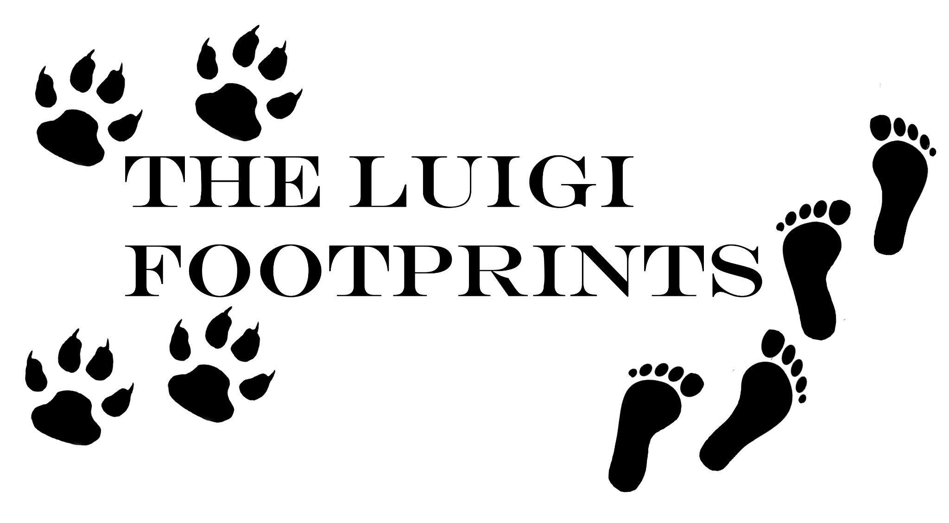

LUIGI FOOTPRINTS FOUNDATION
Empowering Communities, Conserving Nature, and Inspiring Change

Key Contact Person
Peter Karanja | +254 722 509 883

Conservation and Community Empowerment in Amboseli: The Luigi Footprints Foundation Approach

Introduction
The Luigi Footprints Foundation (LFF) has developed a holistic approach to conservation in Kenya's Amboseli ecosystem, demonstrating that protecting wildlife goes hand in hand with supporting local communities. Our multifaceted strategy focuses on education, environmental restoration, community empowerment, and human-wildlife conflict mitigation.

Education and Community Engagement
The Luigi Footprints Foundation recognises education as a powerful catalyst for positive change, understanding its potential to shape individuals, communities, and future conservation efforts. Our approach goes beyond traditional learning, aiming to develop wholesome leaders who will inherit and protect our planet through both formal and informal educational initiatives.
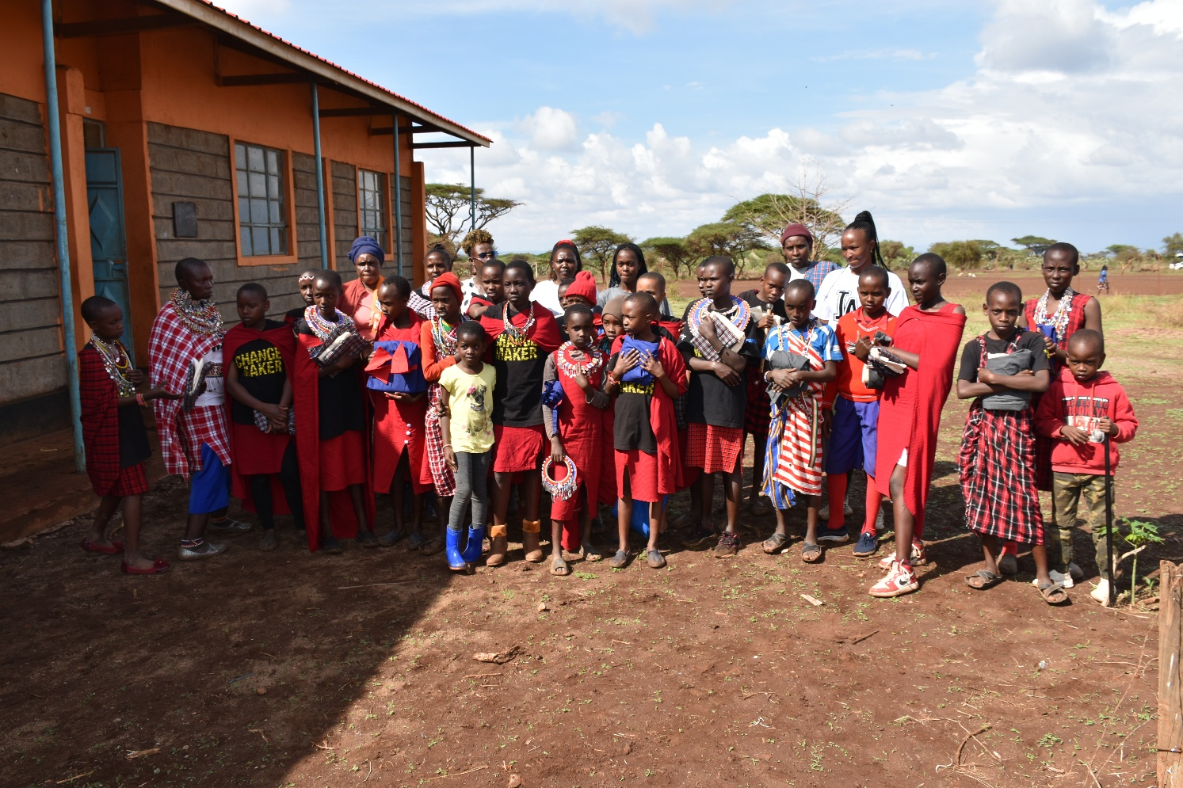

At the heart of our educational mission is a commitment to providing transformative opportunities for students. We have awarded full scholarships to three high-performing students, supporting their secondary education and recognising their exceptional academic achievements and community involvement. The Own Your Choir program has been particularly instrumental in nurturing their talents, showcasing how leadership and environmental awareness can intersect through creative expression.
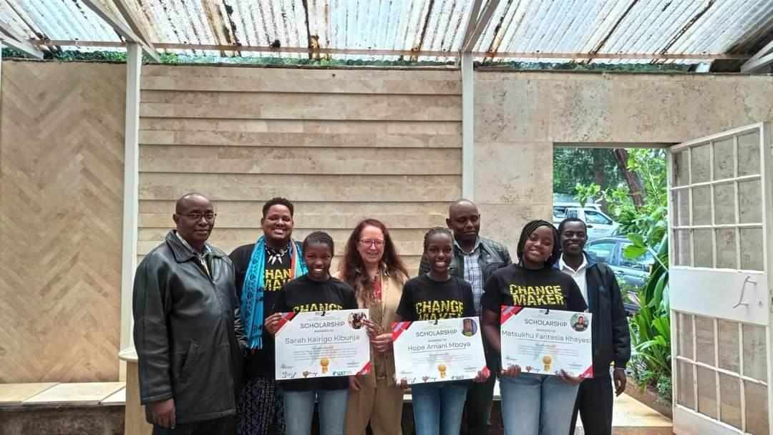
Our educational efforts focus on equipping the younger generation with critical conservation knowledge and skills. Through programs like the Empower School Program, which has reached 2,553 students across five schools in the Amboseli Buffer Zone and Tsavo West, we aim to develop future conservation champions. In collaboration with the Amboseli Trust for Elephants, we organise Conservation Development Workshops that train Elephant Ambassadors, empowering young conservationists with in-depth knowledge of animal behaviour and leadership skills.
The Amboseli OYC Choir remains an innovative initiative that uses traditional arts to raise awareness about conservation, tourism, and cultural topics. Through music, dance, and poetry, young talents are transformed into ambassadors of coexistence, demonstrating our belief that education extends beyond classroom learning to creative and engaging forms of communication.

Environmental Restoration Efforts
LFF's environmental restoration efforts are embodied by the Olchani Project, a holistic approach to conservation in the Amboseli Ecosystem. Rooted in the philosophy of coexistence, this initiative seeks to restore balance by regenerating critical landscapes and maintaining wildlife corridors that ensure both wildlife and communities can flourish.
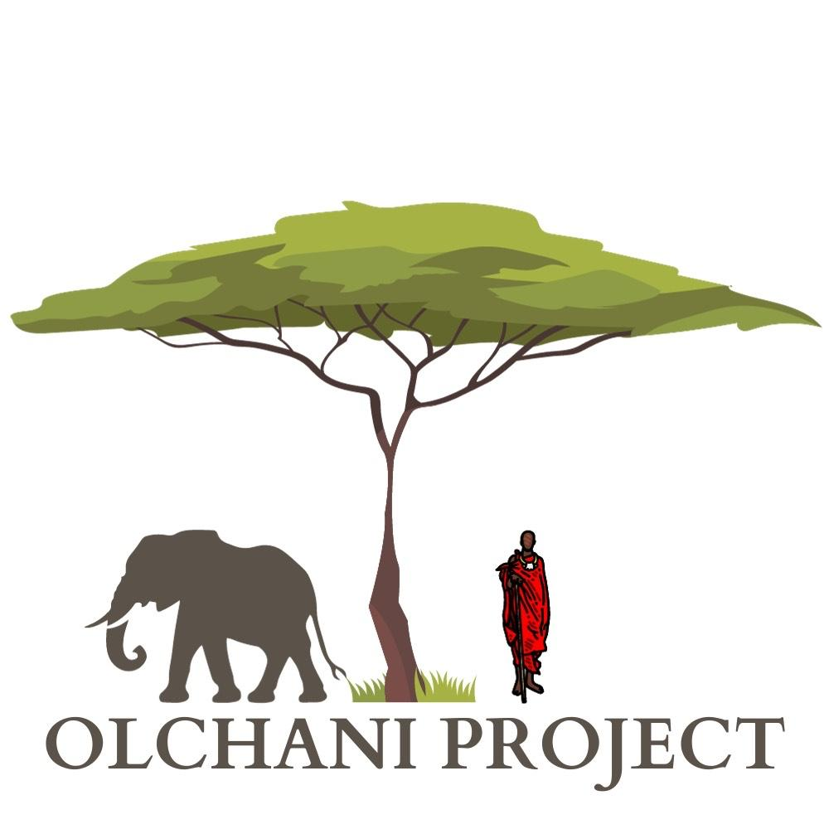 | 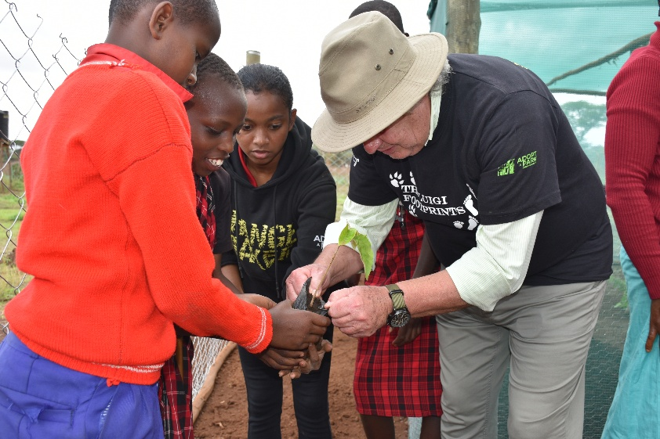
In practical terms, LFF has made significant strides in environmental restoration. In Nairobi National Park's Ubuntu Enclosure, they have planted over 2,000 trees, with an additional 1,500 trees planted in Amboseli and plans to expand to over 3,000. The foundation has established four community-run tree nurseries with a growing capacity of 42,000 seedlings, strategically located in the Ildepen community, Osoit Community, KWS Headquarters, and Oldoinyo Primary School.
What sets our approach apart is the emphasis on community involvement. Over 500 women and 150 youth have been empowered through tree restoration projects, ensuring local participation and ownership in environmental conservation. By placing communities at the centre of these efforts, we transform conservation from a distant concept to a collaborative, sustainable practice that advances the broader "Room to Roam" vision, benefiting both people and wildlife.

Community Empowerment and Economic Development
Understanding that conservation cannot succeed without addressing local economic needs, LFF has launched several innovative initiatives. The Olchani #TreesForPeople project and the Dignity Tailors program are prime examples of how environmental protection can be linked to economic opportunity.
The Dignity Tailors program brings together local women to create arts and crafts, providing them with income-generating opportunities. Perhaps most inspiring is the story of the Ildepen women's group, who established a wholesale shop (Inkaramatak Ildepen Masai Ushanga Shop) to sell traditional Maasai beads directly to tourists, eliminating middlemen and promoting community economic independence.
Eco-tourism collaboration stands as another innovative approach to community development. The Luigi Footprints Foundation actively integrates tree planting into its clients' travel experiences, creating a unique intersection of tourism, conservation, and community empowerment. Guests participate in tree planting in the Orreggie enclosure, purchasing trees cultivated by local community members and women. This approach not only supports reforestation efforts but also provides direct income to local communities while offering tourists a meaningful, immersive experience that deepens their understanding of the Maasai's traditional knowledge and evolving relationship with the land.

Innovative Human-Wildlife Conflict Mitigation
LFF has developed creative solutions to reduce conflicts between local communities and wildlife. Strategies include:
- Using predator deterrent lights to protect Maasai villages
- Implementing a beekeeping project that both prevents wildlife from entering villages and provides an additional income source

Additional Conservation Initiatives
Beyond our core programs, LFF has implemented critical conservation efforts across various fronts. The Dignity Housing Project exemplifies our commitment to those who protect wildlife, providing self-contained container homes for rhino rangers in Nairobi National Park. These improved living conditions enhance ranger security, motivation, and performance, directly supporting wildlife protection.
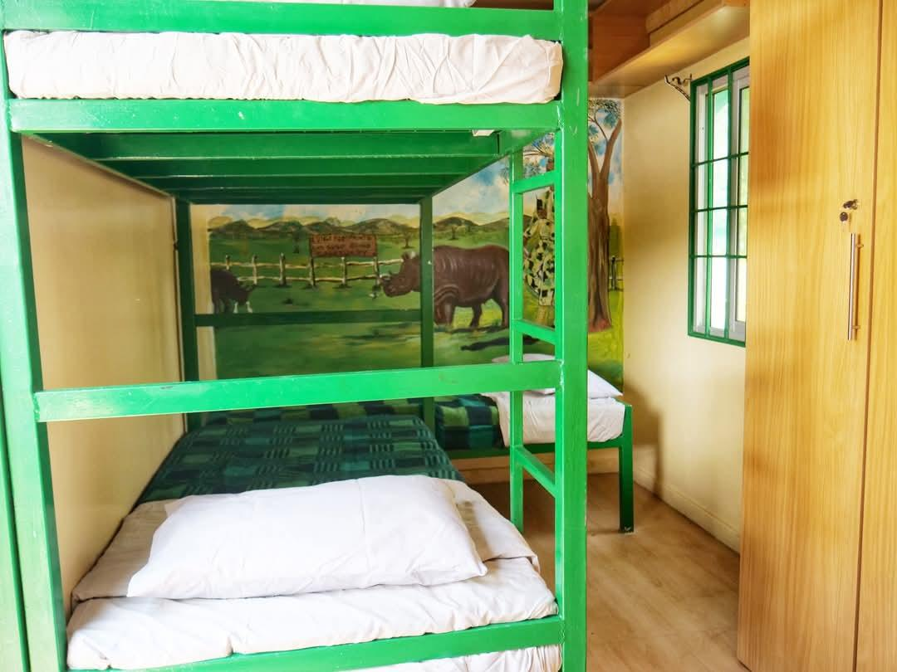 | 
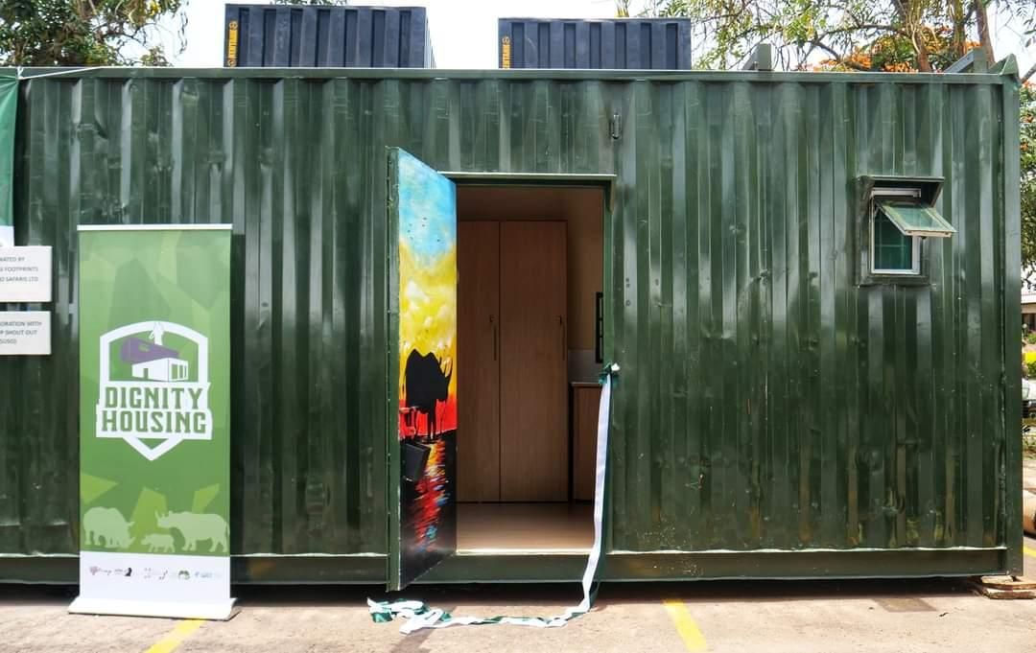 | 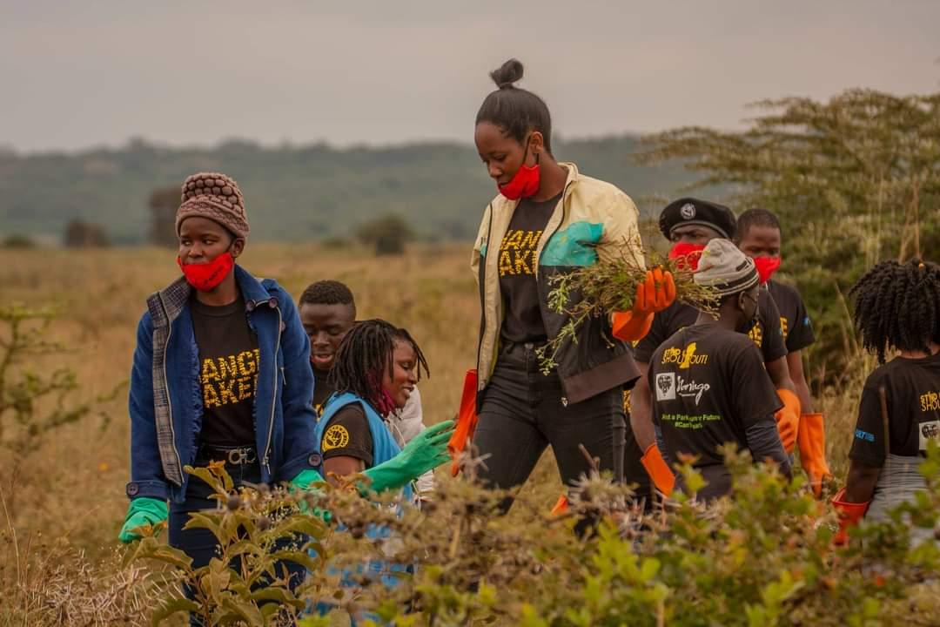
We have also engaged in ecological management, partnering with Stand-Up Shout Out to remove invasive parthenium species from Nairobi National Park. This initiative not only supports park health but also empowers local youth and community members by providing economic opportunities and creating a sense of park ownership.
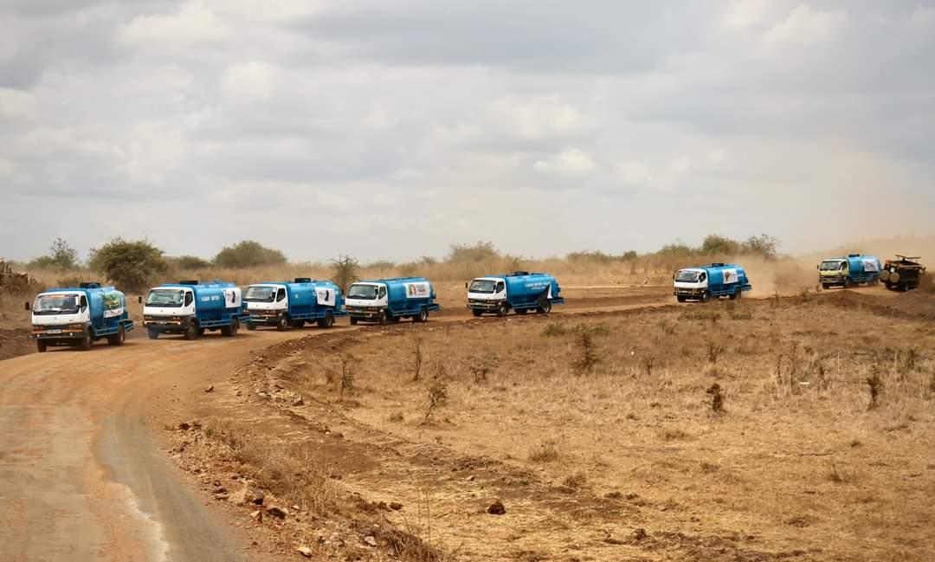 | 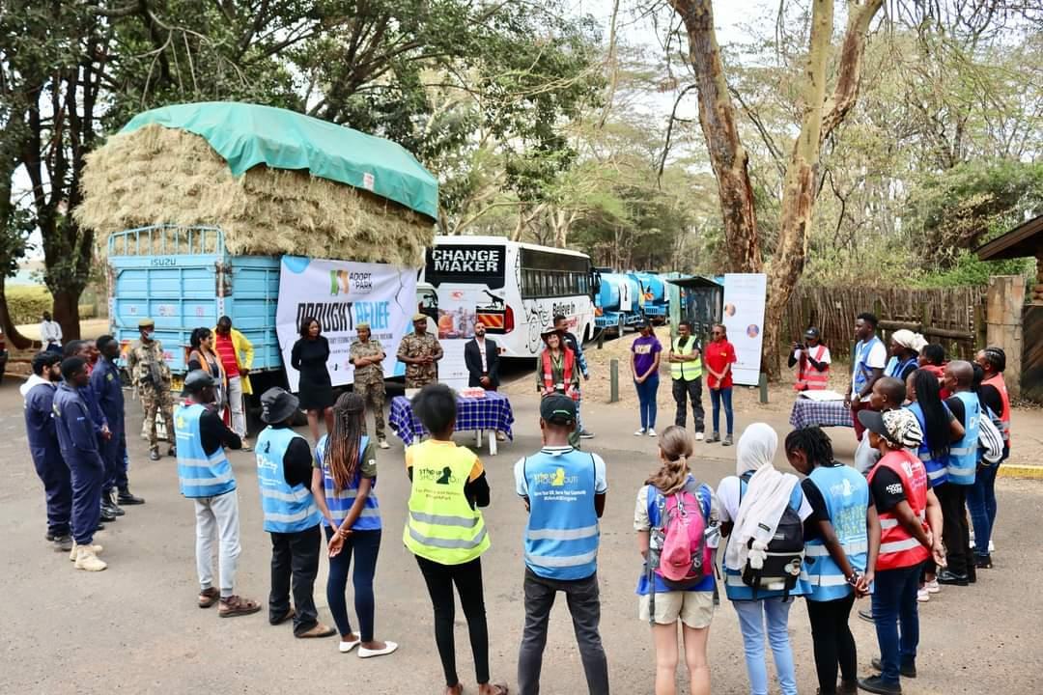
During the 2021/2022 drought, LFF collaborated with the Kenya Wildlife Service to provide essential water trucking and hay distribution, demonstrating our responsive approach to wildlife conservation during critical environmental challenges.
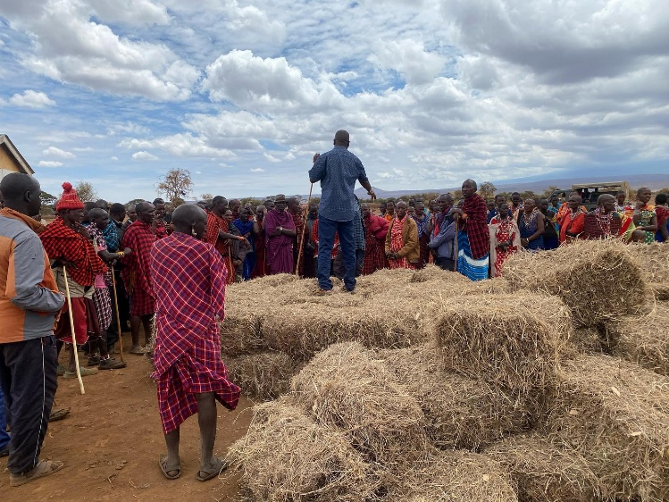 | 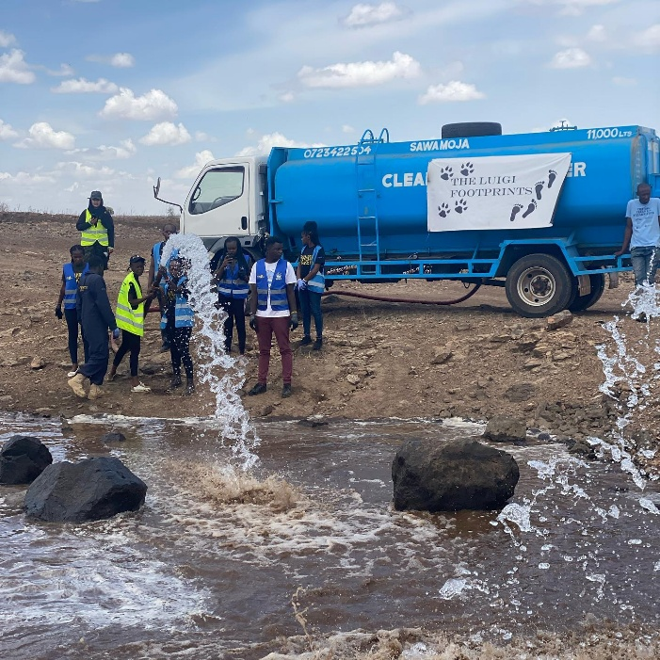

Guiding Philosophy
The foundation's approach is encapsulated in its powerful statement: "Dignity for Communities is equal to Protection for Wildlife." This philosophy recognises that true conservation can only be achieved by supporting and respecting local communities, creating a symbiotic relationship between human development and wildlife protection.

Looking Forward
Through its comprehensive and compassionate approach, the Luigi Footprints Foundation not only protects wildlife but also builds a sustainable model of conservation that empowers local communities to preserve their cultural heritage and ensures the long-term survival of Kenya's precious ecosystems.
We continue to inspire hope, demonstrating that with creativity, respect, and a collaborative spirit, it is possible to create meaningful change that benefits both people and the natural world.

